18.19: 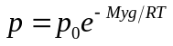from Example 18.4.

Eq. (18.5) says 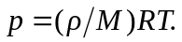 Example 18.4 assumes a constant 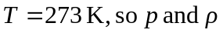are directly proportional and we can write

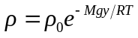
For 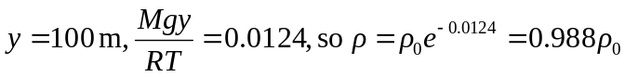

The density at sea level is 1.2% larger than the density at 